SWECC004 — Visual crown assessment
Defoliation, transparency, dieback and epicormic growth
Natuurbegraafplaats Huis ter Heide, De Moer (Zeist) — nine oaks
Nālani Balcells · Avans University of Applied Sciences · June 2026

1. Purpose and protocol
Visual crown assessment provides the most direct, integrative measure of oak vitality available in the field, because crown condition reflects the cumulative effect of every belowground, leaf-level and atmospheric stressor on the tree. For SWECC004 the standardised ICP Forests categories were used at each tree: defoliation class on the 0–4 scale plus a percentage estimate, crown transparency in 5 % steps, crown dieback in 5 % steps, and epicormic growth on a 0–2 scale together with notes on shoot location. Two trained observers scored each tree independently from the same observation position, and the per-tree value reported here is the mean of the two observers.
The dataset covers all seven trees used in the lab work (FT01–FT03 Bokashi, NFT04–NFT06 Untreated, HT07 Healthy reference) plus two additional healthy-reference candidates (HT08, HT09) that were scored alongside HT07 but not sampled for lab analysis. Where a value is reported for a treatment-level mean below, only the seven study trees are included, so the visual signal is directly comparable with the leaf, soil and PhotoFolia datasets.

2. Per-tree results
The per-tree picture (Figure 1) sorts the nine trees cleanly along a defoliation gradient that runs from the healthy-reference cluster (5–25 % defoliation across HT07/08/09) up through FT03 (17.5 %), FT02 (32.5 %), NFT05 (37.5 %), NFT06 (60 %), FT01 (62.5 %) and finally NFT04 (80 %). Two within-treatment observations are immediately visible. First, the bokashi treatment shows a wide internal spread — FT03 looks almost as healthy as the reference trees, while FT01 looks worse than two of the three untreated trees. Second, the untreated group is dominated by NFT04, which has the worst score on every visual metric and is the only tree in the dataset with 80 % defoliation.
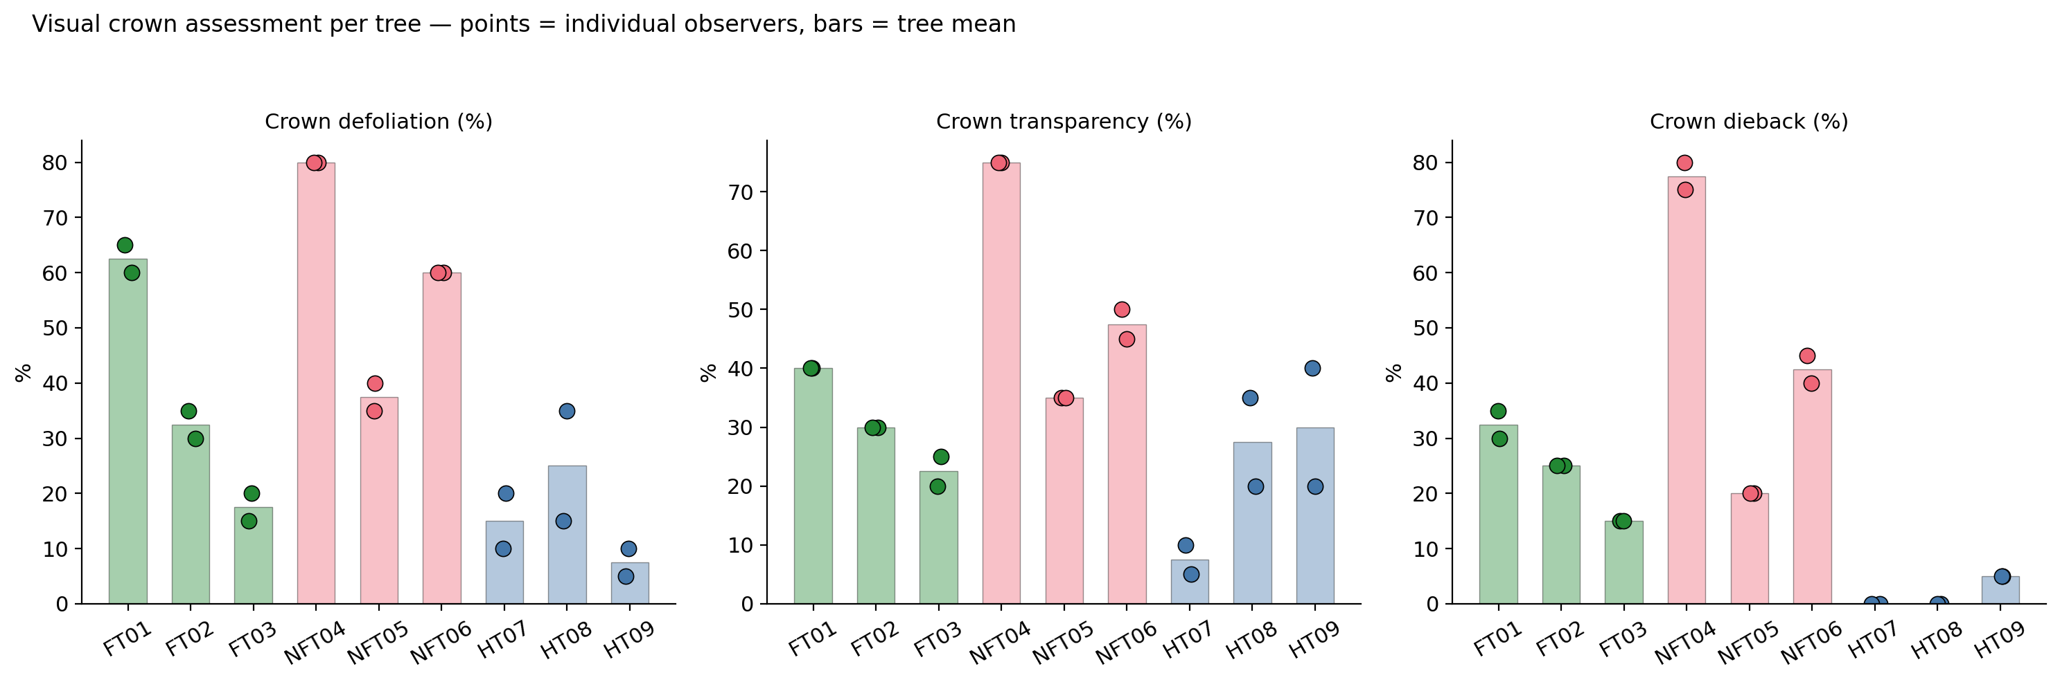
Figure 1. Visual crown assessment per tree. Bars show the two-observer mean; points are the individual observer scores. Defoliation, transparency and dieback are all percentages.

3. Treatment-group comparison
Aggregated to treatment level (Figure 2), defoliation increases monotonically from the healthy reference through bokashi to untreated. Healthy reference trees average 15.8 % defoliation (range 5–35), bokashi trees average 37.5 % (range 15–65), and untreated trees average 59.2 % (range 35–80). The bokashi–untreated separation of about 22 percentage points is large in absolute terms and goes in the same direction on every other crown metric: transparency averages 30.8 % under bokashi against 52.5 % untreated, dieback 24.2 % against 46.7 %, and epicormic-growth scores cluster at 0 for the bokashi group against 1–2 for the untreated group. The visual evidence is therefore the strongest single argument in the entire dataset that bokashi has a positive effect on oak vitality at this site.
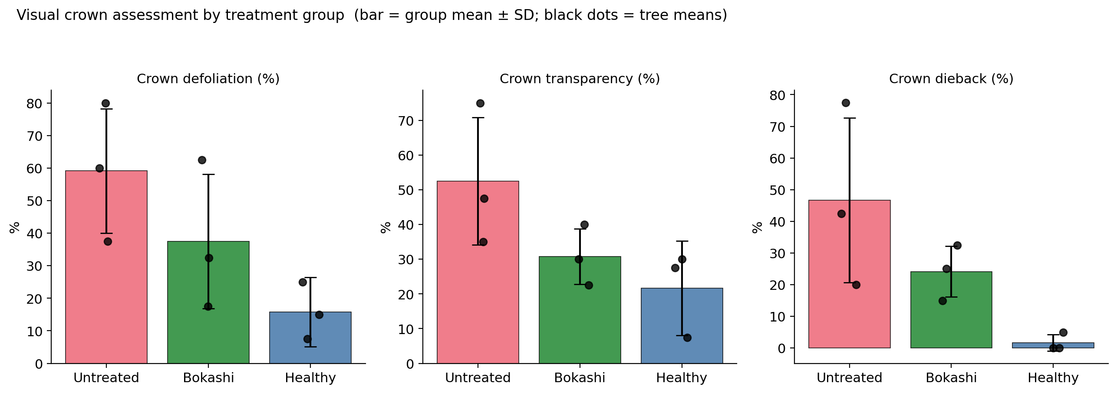
Figure 2. Group means for the three crown metrics. Bars show the group mean with one SD; black dots are the per-tree means.

4. Inter-observer agreement
Crown scoring is a subjective measurement and is therefore only useful as a monitoring metric if independent observers reach similar values. Figure 3 plots Observer 2 against Observer 1 for each tree on each of the three percentage metrics. Agreement is excellent on defoliation (mean absolute difference 3.9 percentage points between observers, well within the 5 % rounding step the protocol uses) and on transparency (5.6 points), and very good on dieback (3.3 points). All pair-points lie close to the 1:1 line and the largest disagreement on any tree on any metric is 20 percentage points (HT08 on defoliation), which the two observers attributed to a single low-density branch that one of them included and the other excluded.
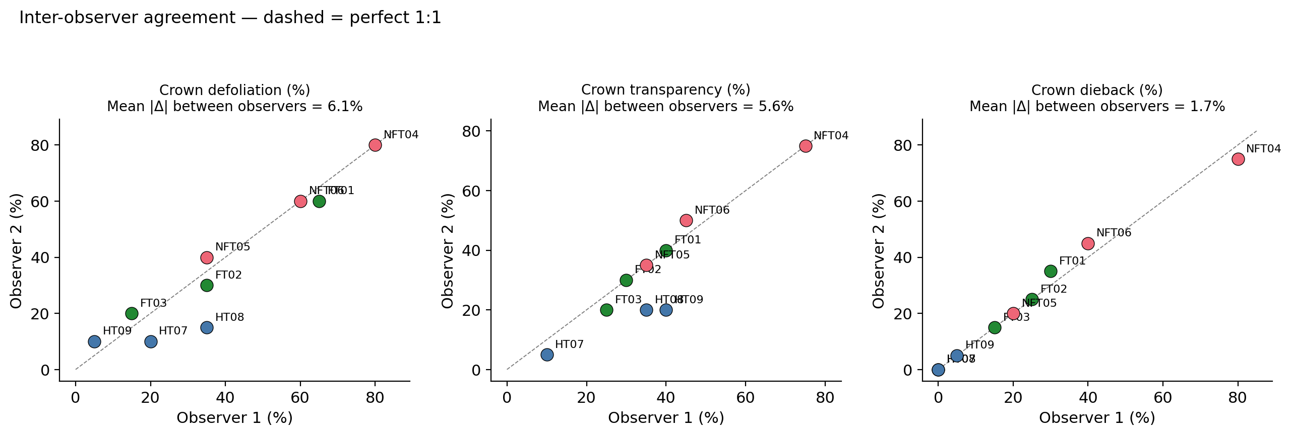
Figure 3. Inter-observer agreement. Each point is one tree; dashed line is perfect 1:1. Mean absolute difference between observers shown above each panel.

5. Integration with the other substrates
The crown assessment is consistent with the leaf, soil and PhotoFolia signals on three specific points and adds independent weight to two of the four-substrate conclusions. First, FT01 is the within-bokashi outlier on every soil-physical indicator (slow infiltration, low water content, low earthworm density) and on the lab leaf-chlorophyll measurement; the crown assessment shows that this is mirrored externally — FT01 has the lowest crown vitality of any bokashi tree. Second, NFT04 has the driest soil and the lowest soil phosphate and ammonium of any tree, and the crown assessment again shows the worst external symptoms: 80 % defoliation, 75 % transparency and 77.5 % dieback. Third, at the treatment-group level the bokashi-trees-have-better-crowns picture is the most clear-cut evidence yet for a positive bokashi effect on oak vitality at this site — a 22-percentage-point reduction in defoliation is a larger and more robust effect than the soil-phosphate increase that drives the soil signal, because the crown metric integrates over the whole tree and the whole growing season rather than over a single soil-chemistry snapshot.

6. Limitations
Three limitations apply. First, the assessment is a single time point in May 2026 with two observers per tree; repeated assessments across the growing season and across years are needed before the 22-percentage-point bokashi–untreated separation can be reported with confidence as a stable site-level effect. Second, NFT04 alone contributes a large fraction of the untreated-group mean, so the group separation should not be read as if every untreated tree were worse than every bokashi tree — NFT05 is in fact in line with the bokashi group on defoliation. Third, the healthy-reference dataset is partially noisy: HT07's defoliation percentages were entered by observers using different conventions and the two HT08/HT09 candidates were not lab-sampled, so the healthy reference is treated as a target rather than as a quantitative anchor.

Files in this folder
crown_raw.csv — observer-level scores for every tree (n = 18 rows, 2 observers × 9 trees).
crown_per_tree.csv — per-tree means used in Figures 1–3.
crown_fig1_per_tree.png … crown_fig3_observer_agreement.png — the three figures reproduced in this document.
SWECC004_visual_crown_description.docx — this document.

